A000-AFR-Egy-Ushabti-Deir El Bahri-Dyn 21-Third Intermediate Period, 1069-945 BCE

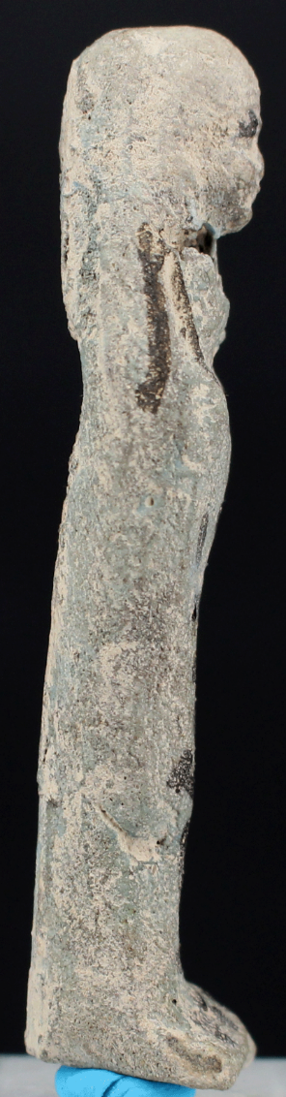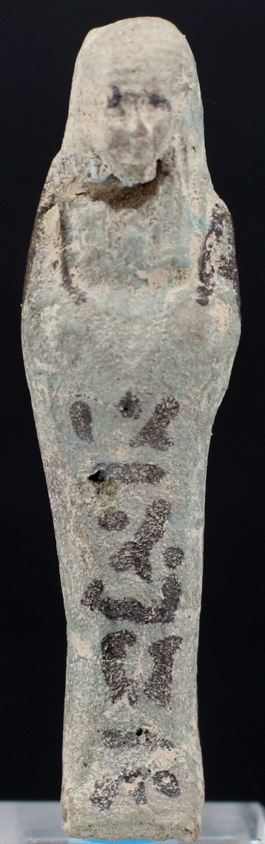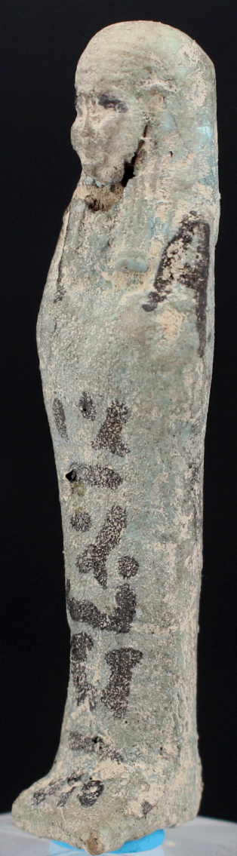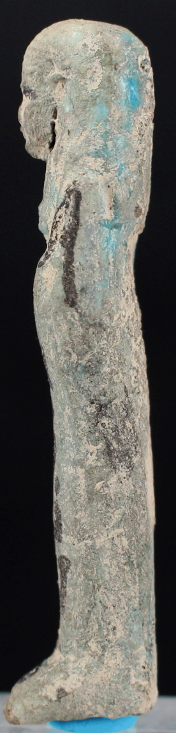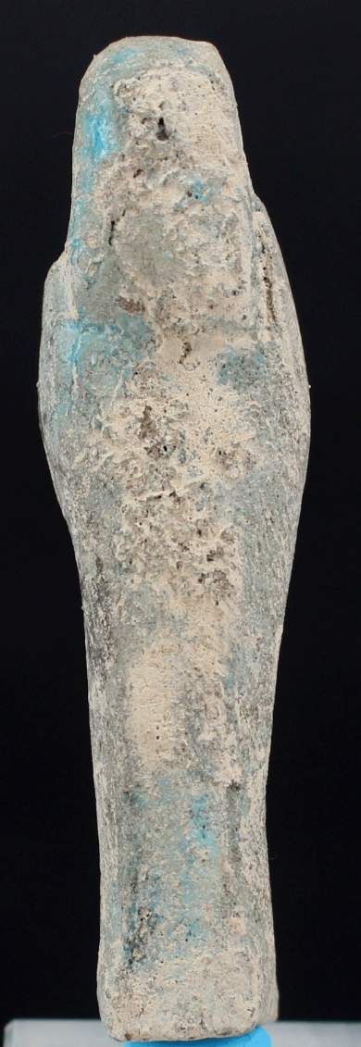

**Case no.: 2**

**Accession Number:**

**Formal Label:** Ushabti-Deir El Bahri-Dyn 21-Third Intermediate Period, 1069-945 BCE

**Display Description:**

Mediocre Modelling except for face, Back coarse, surface white with some Blue faience adhering; produced from area of Thebes.

**LC Classification: NB 75**

**Date or Time Horizon:** Third Intermediate Period, 1069-945 BCE

**Geographical Area:** Deir-el Bahri, Thebes

**Map:**

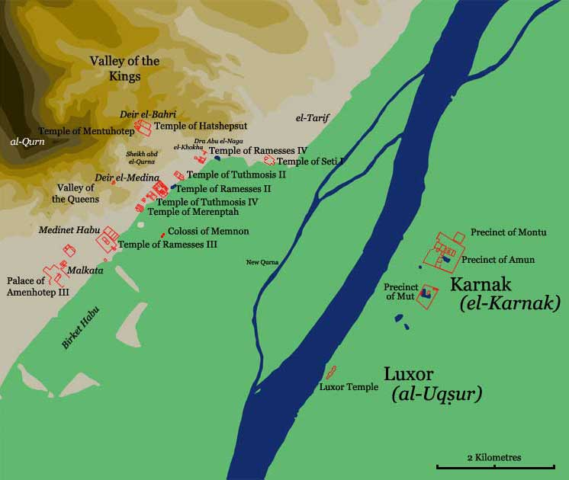

**Location of Deir el Bahri after http://www.odysseyadventures.ca/articles/thebes/thebes_map.jpg**

**GPS coordinates: Latitude:** 25° 44' 10.79" N, **Longitude:** 32° 36' 16.79" E

**Cultural Affiliation:** Third Intermediate Period, 1069-945 BCE

**Media:** ceramic, Blue faience, Black ink

**Dimensions:** 2.8 in, 71-19 mm

**Weight: 3/8 oz, 12 gm**

**Condition: original**

**Provenance:**

The Third Intermediate Period was one of contesting parties. This left the artisans in precarious positions resulting in less developed capabilities of ateliers and less production of fine wares due to less expendable incomes.

**References:**

Schneider, H.D. 1977. *Shabtis: An introduction to the history of ancient Egyptian funerary statuettes with a catalogue of the collection of shabtis in the National Museum of Antiquities at Leiden*. Leiden: Rijksmuseum van oudheden.